CS 590 Module Five Assignment – Document Databases and MongoDB
1. Creating a New MongoDB User
A new user was created successfully in MongoDB using the db.createUser() command. The command returned { ok: 1 }, confirming successful creation of the user with access to the childnutrition database.
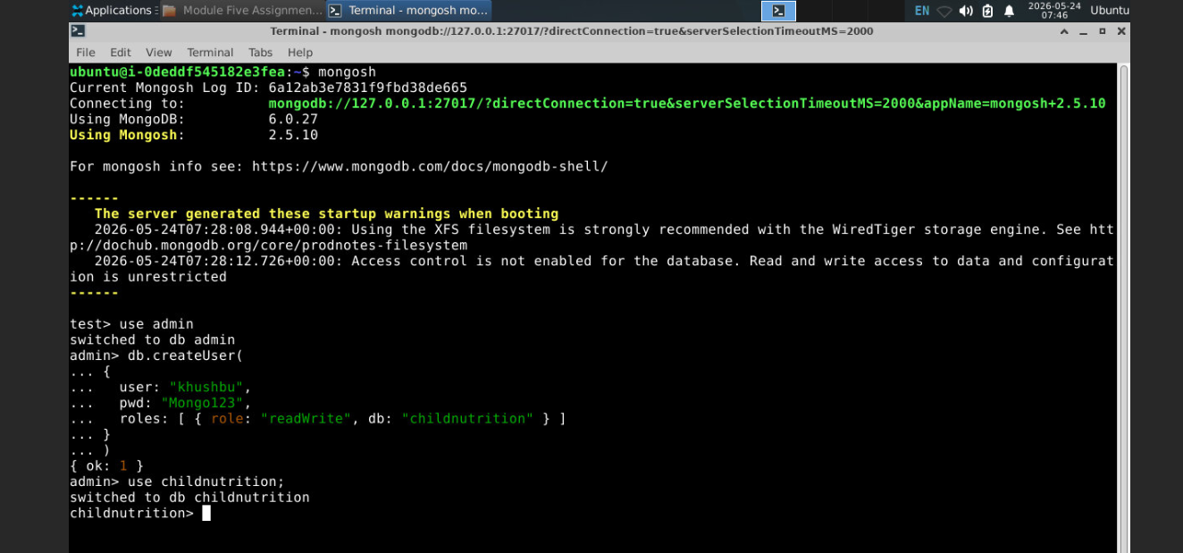
2. ETL Process
The ETL process was completed using MongoDB’s mongoimport tool in Codio. The following files were imported:
1) Module_Five_Nut_Descs.json
2) Module_Five_Nut_Vals.json
Two collections were created:
1) nut_descs
2) nut_vals
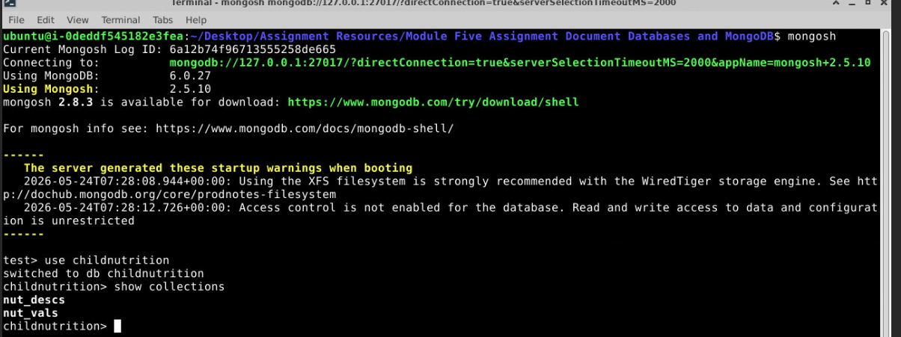
3. Datatypes of Imported Fields
After importing the JSON files into MongoDB, the data was stored as BSON documents inside collections.
A sample record from nut_vals showed the following field types:
Field | Datatype
_id | ObjectId
Cn code | String
Nutrient code | String
Nutrient value | String
Per unit | String
Value type code | String
Source code | String
Date added | String
Last modified | String

Are these expected datatypes?
Yes, these are expected datatypes. The original JSON files store most values as text strings, so MongoDB imported them as strings. MongoDB also automatically generated an _id field for each document using the ObjectId datatype.
4. How MongoDB Breaks Out Data Into Separate Records
MongoDB stores data as documents inside collections. Each nutrient value is stored as an individual JSON-like document inside the nut_vals collection. This differs from PostgreSQL, where data is stored in rows and columns inside tables. MongoDB’s document model provides flexibility and allows related data to be stored together.
5. Query Created and Executed
The following query was executed to retrieve nutrient records where Nutrient code = 203:
db.nut_vals.find({ "row.Nutrient code": "203" }).limit(5)
This query returned nutrient records matching Nutrient code 203.
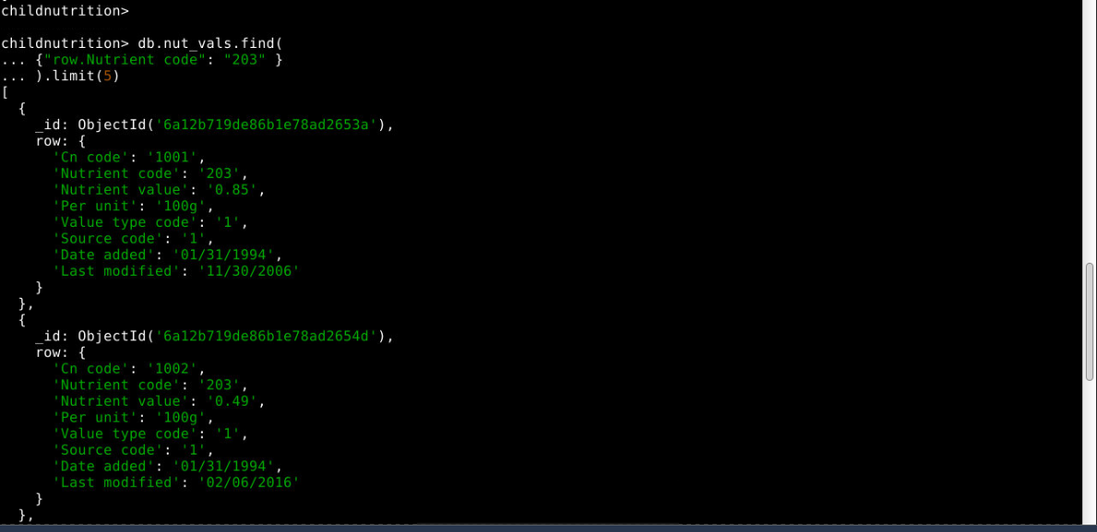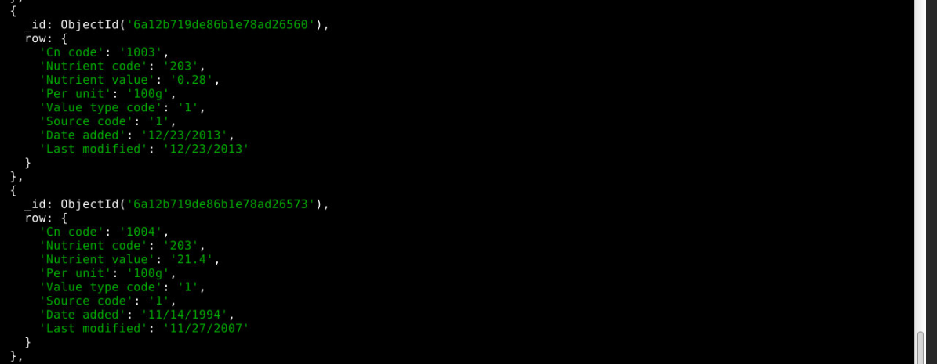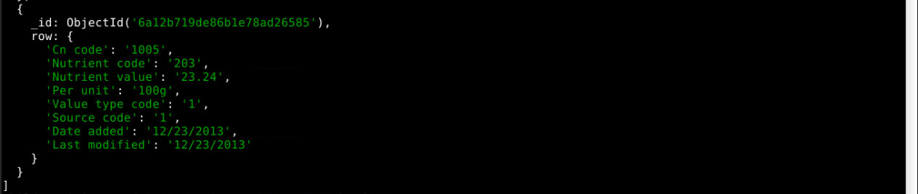
6. Comparison of MongoDB and PostgreSQL
PostgreSQL is a relational database that stores data in tables with rows and columns. It uses a fixed schema and supports joins using primary and foreign keys.
MongoDB is a document-oriented NoSQL database that stores data in collections using JSON/BSON documents. It offers schema flexibility and easier horizontal scaling.
PostgreSQL uses SQL queries such as SELECT * FROM nutrient_values;, while MongoDB uses Mongo Query Language commands such as db.nut_vals.find().
7. Recommended Database Solution
Based on my understanding of both SQL and document databases, PostgreSQL is the more optimal solution for the Child Nutrition database. The Child Nutrition database contains structured and highly related data between nutrient descriptions and nutrient values.
MongoDB offers flexibility and scalability, which is useful for rapidly changing or semi-structured data.
However, because nutritional data is organized, structured, and relational, PostgreSQL is the better database choice for this use case.

